**SMART BRIDGE**

**SMART INVESTMENT PREDICTION**

TEAM NAME:PHEONIX

TEAM MEMBERS :-

M.Kasturi

Ch.Prashanthi

T.Sandeep

M.pranay

**CONTENT**

1.Introduction

1.1 Introduction

1.2 Objectives Of Research

1.3 Problem Statement

1.4 Industry Profile

2.Review Of Literature

3.Data Collection

4.Methodology

4.1 Exploratory Data Analysis

4.1.1 Dataset

4.2 Statistical Methods and Data Visualization

5. Findings and Suggestions

6.Conclusion

­­­­ **SMART INVESTMENT PREDICTION**

1.INTRODUCTION

Nowadays,as the value of money is increasing,people are seen finding secret mantras of smart investment tips.There is a very thin line between investment and smart investment.Therefore,make sure you do it right by choosing a right investment plan.

Are you one of those?But as a matter of fact,investment smartly is no rocket science and there are no secret mantras for it.You just need to ask yourself a few questions.What are the best ways to invest money?why do you want to invest money?where to invest money?

* Understand Best Money Investments Before Investing
* Keep Calm & Know Money Investment Options­­­
* Include Tax Saving Investment

To invest is to allocate money in the expectation of some benefit in the future. In finance, the benefit from an investment is called a return.The return may consist of a gain (or loss) realised from the sale of property or an investment,unrealised capital appreciation (or depreciation), or investment income such as dividends, interest, rental income etc., or a combination of capital gain and income.

Prediction is using for getting high probability of future benifits (high income),but not always based upon experiance or knowledge.

Investment Prediction:The return may also include currency gains or losses due to changes in foreign currency exchange rates.

There are two prices that are critical for any investor to know: the current price of the investment he or she owns,or plans to own and its future selling price. Despite this, investors are constantly reviewing past pricing history and using it to influence their future investment decisions.

1.1 OBJECTIVES OF RESEARCH

The main objective of the project is to keep the customers aware of the best companies to invest, which gives us good profits.Here,input for the project is dataset.They invest based on the grade of the company for safety growth and income.

Depending on the life stage and risk appetite of the investor, there are three main objectives of investment: safety, growth and income. Every investor invests with a specific objective in mind, and each investment has its own unique set of benefits and risks. Let us understand these objectives in detail

1.2PROBLEM STATEMENT

Many of us are not aware of the companies which gives us good profits so we have comeup with a solution which helps the clients to compares and gives the best company to invest .

Therefore,we are developing a model to predict the grade of the company.This model typically utilizes a database of parameters that have been previously tested.The user can input parameters data by matching their parameters found in database;the analysis can then be calculated.

2.REVIEW OF LITERATURE

The existing literature has utilised the variety of classifiers available. The notable ones and better performance giving classifiers among them are artificial neural networks (ANNs), support vector machines (SVMs), Naive Bayes, and Adaboost. Further, the pairwise classification framework has been proposed to enhance the recognition rate of Investment classification . A real-time database with Smart Investment has been created and made as a benchmark . Later on, experiments have been conducted on the same dataset by considering it as a benchmark. Later the research has focused on collecting the varieties of dataset and a new dataset to evaluate algorithms to recognize food which helps to monitor diets. The database has been built which contains more than 100 instances of Grade of company.

With the advent of the digital computer, Investment prediction has since moved into the technological realm. The most prominent technique involves the use of artificial neural networks (ANNs) and Genetic Algorithms(GA). ANNs can be thought of as mathematical function approximators. The most common form of ANN in use for Investment prediction is the feed forward network utilizing the backward propagation of errors algorithm to update the network weights. These networks are commonly referred to as Backpropagation networks. Another form of ANN that is more appropriate for Investment prediction is the time recurrent neural network (RNN) or time delay neural network (TDNN). Examples of RNN and TDNN are the Elman, Jordan, and Elman-Jordan networks. (See the Elman And Jordan Networks)..

Machine learning and artificial intelligence-based projects are obviously what the future holds. We want better personalization, smarter recommendations, and improved search functionality. Our apps can see, hear, and respond – that’s what artificial intelligence (AI) has brought, enhancing the user experience and creating value across many industries.

3. Data Collection :

Our database contains 5 fields.

The fields used in our model are :

1.Grade of the company

2.Number of offline projects

3.Number of client projects

4.Net_turnover

5.Share_price

Based on the Grade of the Company the clients invest the projects.

4.METHODOLOGY

The methodology we used in our model is data classification. For this we used Decision Tree,Random Forest ,K Nearest Neighbor and Confusion Matix.

Decision Tree:Decision Trees are a type of Supervised Machine Learning .where the data is continuously split according to a certain parameter. The tree can be explained by two entities, namely decision nodes and leaves. The leaves are the decisions or the final outcomes. And the decision nodes are where the data is split.

Random Forest : Random forests are an ensemble learning method for classification, regression and constructing a multitude of decision trees at training time and outputting the class that is the mode of the classes (classification) or mean prediction (regression) of the individual trees.

K Nearest Neighbor: The model representation for KNN is the entire training dataset.

Efficient implementations can store the data using complex data structures like k-d trees to make look-up and matching of new patterns during prediction efficient.

Confusion Matrix:Classification accuracy alone can be misleading if you have an unequal number of observations in each class or if you have more than two classes in your dataset.

Calculating a confusion matrix can give you a better idea of what your classification model is getting right and what types of errors it is making.

4.1.Dataset

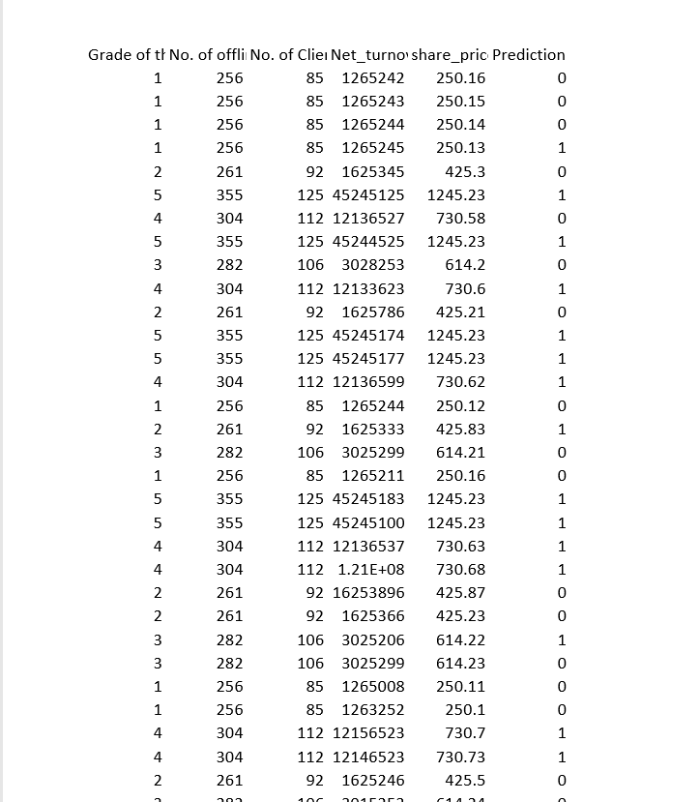

4.1.1: Exploratory Data Analysis

Decision Tree

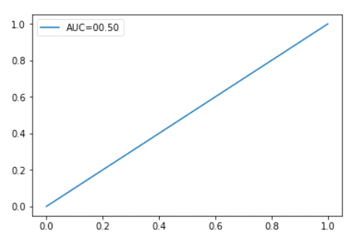

Random Forest

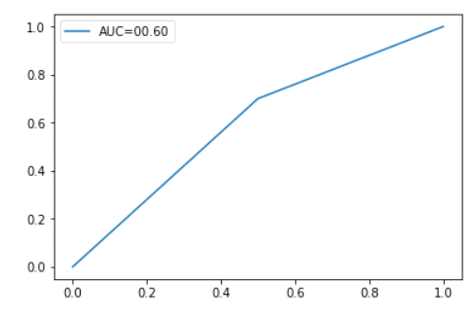

K Nearest Neighbor

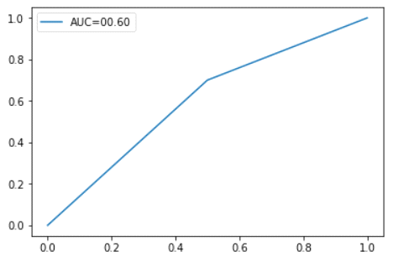

Confusion Matrix

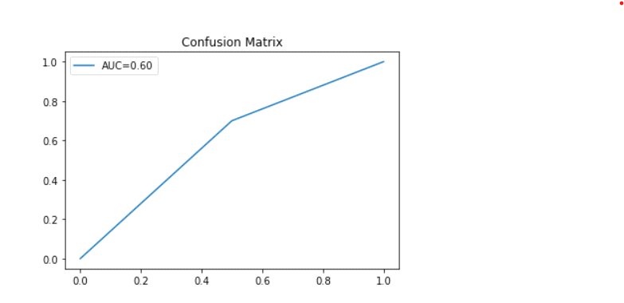

As we got accuracy more in the Random Forest ,so we used random forest alogorithm for Prediction.

5.FINDINGS AND SUGGESSTIONS

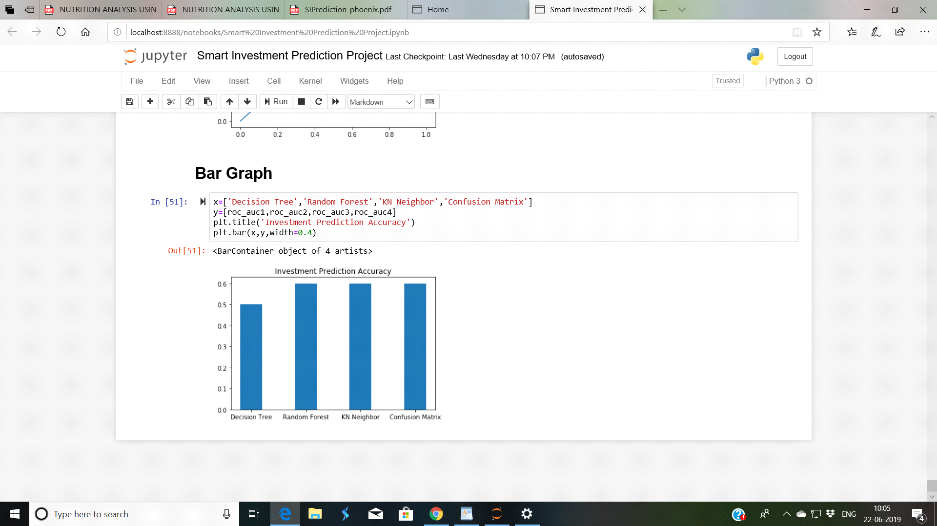

Prediction for Smart Investment

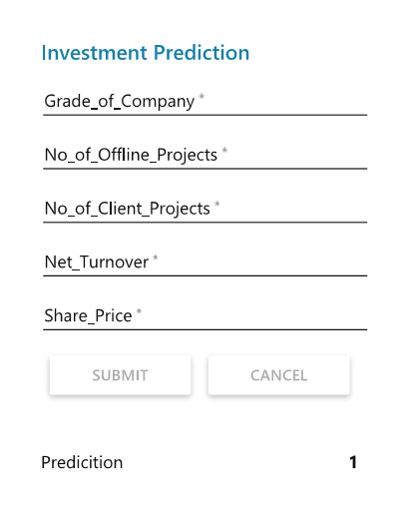

6.CONCLUSION:

Investment is important to achieve individual goal.Investment means we have money,then we need to make analysis to invest the money,and expected get return in future .If the investment are run early,then we will make a lot of profit.Here, based on the grades of the company,the offline projects , client projects ,turn_over and Share Price.We came to the conclusion to invest in or not.If the prediction is 1 then it is the best company to invest else not.